## **Objectives:**

The aim of this lab is to practice set operations. We do this based on the HR database described below.

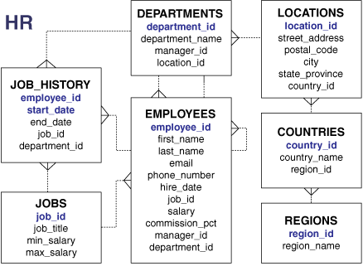

## **Lab Work:**

1. Display the current and previous job details of all employees. Display each employee only once.

SELECT employee_id, job_id

FROM employees

UNION

SELECT employee_id, job_id

FROM job_history;

SELECT employee_id, job_id, department_id

FROM employees

UNION ALL

SELECT employee_id, job_id, department_id

FROM job_history

ORDER BY employee_id;

1. Display the employee IDs and job IDs of those employees who currently have a job title that is the same as their job title when they were initially hired (that is, they changed jobs but have now gone back to doing their original job).

SELECT employee_id, job_id

FROM employees

INTERSECT

SELECT employee_id, job_id

FROM job_history;

1. Display the employee IDs of those employees who have not changed their jobs even once.

SELECT employee_id,job_id

FROM employees

MINUS

SELECT employee_id,job_id

FROM job_history;

1. We can use set operators for sets that are not compatible. In the case we use dummy columns to match the two sets

SELECT department_id, TO_NUMBER(null)

location, hire_date

FROM employees

UNION

SELECT department_id, location_id, TO_DATE(null)

FROM departments;

In this case, we added to_number(null) to compensate for the absence of location in the employee table. Likewise, to_date(null) is used to compensate for the absence of hire date in the departments table.

Another example

SELECT employee_id, job_id,salary

FROM employees

UNION

SELECT employee_id, job_id,0

FROM job_history;

1. Produce an English sentence using two UNION operators.

COLUMN a_dummy NOPRINT

SELECT 'sing' AS "My dream", 3 a_dummy

FROM dual

UNION

SELECT 'I''d like to teach', 1 a_dummy

FROM dual

UNION

SELECT 'the world to', 2 a_dummy

FROM dual

ORDER BY a_dummy;

## **Class Exercise:**

In class exercises:

1. The HR department needs a list of department IDs for departments that do not containthe job ID ST_CLERK. Use set operators to create this report.
2. The HR department needs a list of countries that have no departments located in them.Display the country ID and the name of the countries. Use set operators to create this report.
3. Produce a list of jobs for departments 10, 50, and 20, in that order. Display job ID anddepartment ID using set operators.
4. Create a report that lists the employee IDs and job IDs of those employees who currently have a job title that is the same as their job title when they were initiallyhired by the company (that is, they changed jobs but have now gone back to doing their original job).
5. The HR department needs a report with the following specifications: Last name and department ID of all the employees from the EMPLOYEES table, regardless of whether or not they belong to a department: Department ID and department name of all the departments from theDEPARTMENTS table, regardless of whether or not they have employees working in Them. Write a compound query to accomplish this.